**QA Checklist**

Convert Ultra to Touch Procedure

**Revision 1.0**

### 28-Mar-2017

**Revision History**

|  |  |  |  |
| --- | --- | --- | --- |
| **Rev. No.** | **Author** | **Date** | **Comments** |
| 1.0 | MM | 03-28-2017 | Initial draft. |
|  |  |  |  |
|  |  |  |  |
|  |  |  |  |
|  |  |  |  |
|  |  |  |  |
|  |  |  |  |
|  |  |  |  |
|  |  |  |  |
|  |  |  |  |
|  |  |  |  |
|  |  |  |  |
|  |  |  |  |
|  |  |  |  |

OBJECTIVE

This procedure provides the user with a list of tasks required to convert an Ultra to Touch on the CAT systems. This includes, but is not limited to draws, rolling time, nightly processing, backups, and interface management.

WARNING!!! CHANGE TIME AND CDC ONLY ON TEST SYSTEM TO SPEED UP TIME. *NEVER* CHANGE ON PRODUCTION SYSTEM!!!

Steps and Comments

Primary: Operator:

CDC: System Date: Actual Date :

1. Sign onto the ES Dashboard.
2. Under Communications click on ‘Terminal Information.’
3. Type in the terminal ID number in the PROSYSV8 ID text box, click on Execute Query

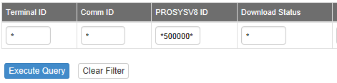

1. The Gemini Ultra terminal information is visable. Click on the view details button to delete terminal from ESConnect. The Delete button is in the upper right hand corner.

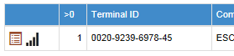

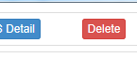

1. Go to Retailer Services/Find a Location. Type the retailer in the Location ID field.
2. On the left side click on ‘TERMINALS’ to drop down a list a terminals that are assigned to the retailer.
3. Click on the desired Gemini Ultra to convert.

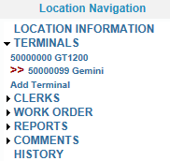

1. Click on the ‘Upgrade to Gemini Touch’ button.



1. Dialogue box will pop up. Click ok to convert Ultra to Touch.

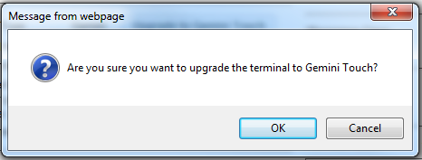

1. Click on the highlighted in blue ES Connect Setup.

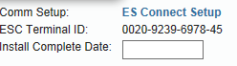

1. Submit the terminal ID to add the terminal successfully.

